**Blake Conrad**

**Advanced Simulations**

**Project 1**

Table of Contents

Technical Report 4

M/M/1 Queue 4

Analysis 4

Recommendation 4

Army Corps of Engineers Dam Simulation 5

Analysis 5

Recommendation 5

Baseball Simulation 5

Analysis 5

Recommendation 6

# Technical Report

## M/M/1 Queue

### Analysis

We have been asked to simulate an M/M/1 queue for 160 hours. We have arrival distributions at Exponential (1/4) and service distributions at Exponential (1/5). There is only one server allowed in this simulation. This queue is built in Python using the Pandas and Numpy libraries.

After building and running the M/M/1 Queue in python, *Figure 1* illustrates the resulting output for analysis. We see from this table the following:

* Average Time in Queue: We can take 21.04/38.18 to arrive at the average time in the queue, which turns out to be 0.55, which is a little over 30 minutes.
* Average Time in System: By adding the total number in the queue and dividing by 38.18, the total time in system, we arrive at the average time in the system, which turns out to be 0.62, which is between 30 and 45 minutes.
* Average Number in Queue: By adding the total number in the queue and dividing by 21.04, the total waiting time in line, we arrive at the average number in the queue, which turns out to be 1.14, just over 1 person in the queue at any given time.
* Average Utilization: We can take the average utilization to arrive at a 0.91 utilization of our single server, which is nearly 100% utilized.

### Recommendation

One meaningful conclusion that can be made is that if people are waiting for over 30 minutes in this queue, the product must be substantially worthwhile. For example, if we are waiting 30 minutes for a burger, this might be too long, however 30 minutes for a new phone or visit to a superstar might be worth it.

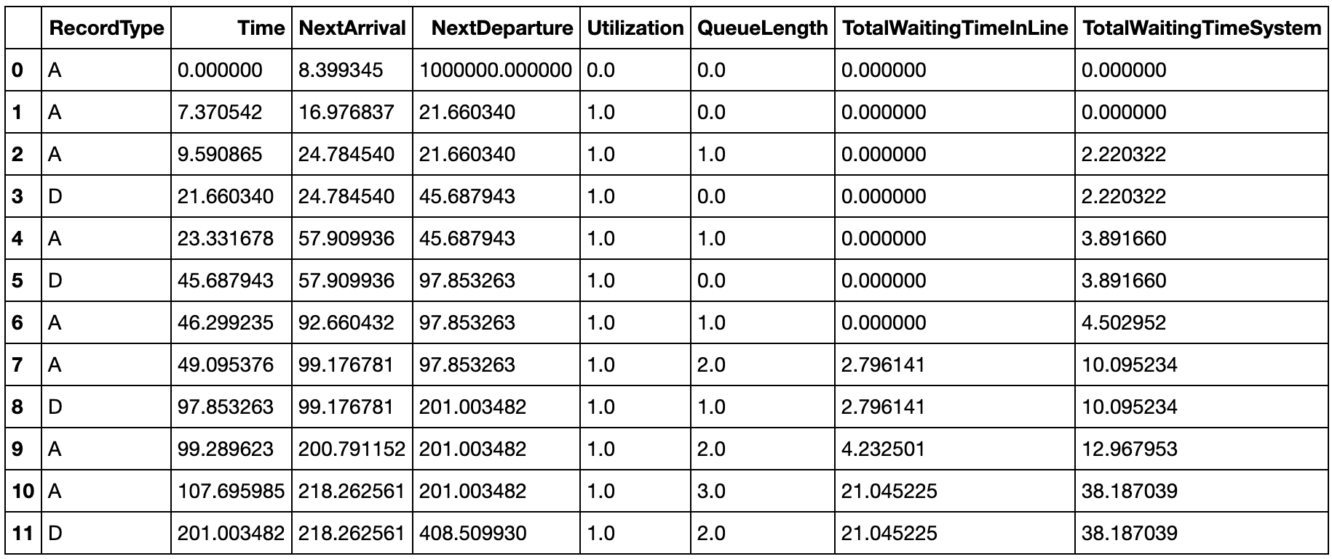

Figure 1 - M/M/1 Queue Output for Analysis

## Army Corps of Engineers Dam Simulation

### Analysis

We have been asked to simulate 30 replications of a dam for the Army Corps of Engineers every 100 years. The objective is to determine a height that will only trigger the floodgates once every 100 year. We build a simulation in python using probabilistic knowledge about each day, the chance of rain, and the amount of height increase the dam ingests. We assume that the max height of water in a simulated dam height rep is a good indicator in aggregate to understand what max height will be necessary to build a real dam that fails only once every 100 years.

### Recommendation

After building the dam simulation with 30 reps of 100 years each, we construct a dataset of average max heights seen in *Figure 2*. If we only want one failure every 100 years, we analyze what the worst case will be and prepare for that, otherwise we will not release the flood gates with our sufficient data provided. Hence, we expect every one-hundred years for the height to be no greater than about *14743.91*. Hence, we will recommend the Army Corps of Engineers to build their dam no greater than about 14743 inches, or 1229 feet. This will cause them to release the flood gates only once if they allow this threshold (i.e., lending to 100 years of good dam structures).

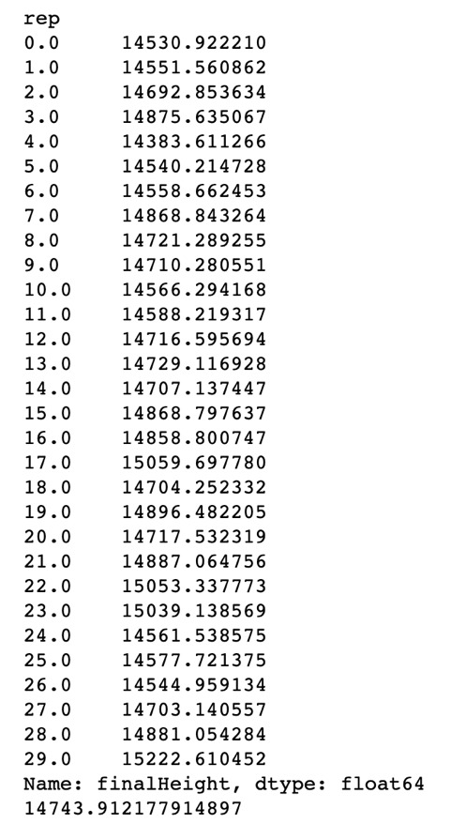

Figure 2 - 30 Replications of 100 years average max water dam heights.

## Baseball Simulation

### Analysis

We have been asked to build a baseball simulation of historical elite player mixtures and their corresponding statistics. We begin by constructing a mini simulation for each of the three teams that are possible; McQuire vs. Gwynn, McQuire vs Hybrid Team, and Gwynn vs. Hybrid Team. We obtain the following results from the simulation:

|  |
| --- |
| McQuire vs. Gwynn |
| Averages Points Scored By McQuire 1.1658062556938962 |
| Average Points Scored By Gwynn 1.032796841785606 |
|  |
| McQuire vs Hybrid Team |
| Averages Points Scored By McQuire 1.1785164666051093 |
| Average Points Scored By Hybrid 1.2449984610649432 |
|  |
| Gwynn vs. Hybrid Team |
| Averages Points Scored By Gwynn 1.2669748627564288 |
| Average Points Scored By Hybrid 1.360011557353366 |

### Recommendation

We see that both McQuire and Gwynn are better together than separate (Great complementary team mates). However without this synergy, McQuire is better than Gwynn in isolation, and they both lose independently to the Hybrid team. We recommend to build a team with good complementary statistics in home runs and consistent single and doubles to build a successful team.